VBM - Remaining Part 3 Kit and Forms Templates

NOTE: Unlike Appendices B & C, provided in editable formats by a separate file (Part 3A…), the following forms are not required to be appended to the VBM Regulations package to be submitted for MAPA review.

Remaining Voter Kit Forms:

VBM-1 - Voting Directions
VBM-2 - Emergency Update Voting Directions
VBM-3 - Ballot Secrecy Envelope
VBM-4 - Return Envelope

Other VBM-adapted Election Forms:

VBM-5 - Notice of Candidates (Replaces MEF-04)
VBM-6 - Poll Box Vote By Mail Tally Sheets - Voter Kits Processed
VBM-7 - Election Day Directions for the Guidance of Voters (Replaces MEF-14)

NOTE: As appropriate, these templates reflect the design guidance provided by MAPA in their 2021 Municipal Election Forms publication for similar required forms (e.g. ballots, directions to voters) used in default election circumstances pursuant to the MEA.

Unless otherwise indicated, all other forms and procedures will generally follow the 2021 MAPA election guidance materials (i.e. 2021 Municipal Election Forms, Guide to Municipal Elections for Elections Officials) available at:
https://www.gov.nl.ca/mpa/local-governance-division/municipal-elections/

In some cases, the timeframes for administering the Department’s required Municipal Election Forms (MEF) must be adjusted to reflect the commencement of the voting period that VBM provides in the place of the emphasis on a single Election Day under the MEA’s default municipal election provisions. For example, Returning Officers should ensure that their election staff complete MEF-09 - the Oath or Affirmation of Returning Officer, Deputy Returning Officer, Poll Clerk, and Other Election Officials - prior to assuming their duties during the VBM voting period. Similarly, they should be mindful that the Oath or Affirmation of Secrecy (MEF-10) should be administered to active election officials, candidates, and candidate’s agents once the VBM voting period commences.

FORM VBM-1

VOTING DIRECTIONS

Use standard 8-1/2” x 11” paper stock - white; double-sided copy ideally.

The following text shall be printed using large plain fonts and spacing (for legibility) in black ink:

FRONT: Insert graphic (arrow) to direct reader to other side of page
Read this first…
Voting Directions
Follow these steps to keep your vote secret and ensure your ballot is not spoiled. A
spoiled ballot cannot be counted. You must:
- Complete your ballot(s) and insert into the white Ballot Secrecy Envelope (A).
- Seal Envelope A -
- Sign and print your name on the yellow Declaration Form.
- Insert your completed Declaration Form and sealed Ballot Secrecy Envelope into
the yellow Return Envelope (B).
- Seal Envelope B -
Your ballot kit is now complete.
You may return it to the [insert instruction, e.g. Town Offices during regular office hours and/or dropbox] or to your designated poll location on Election Day.

Mock-ups:
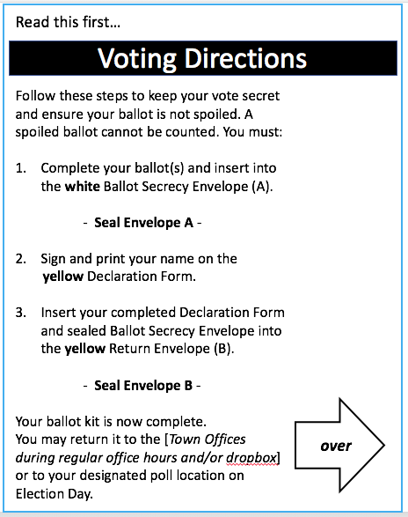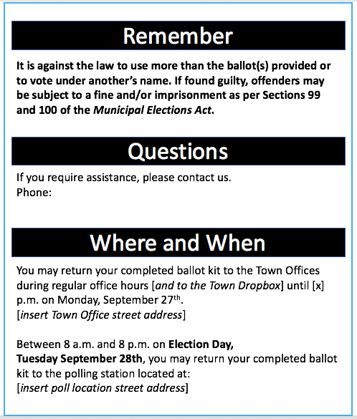

FORM VBM-1

VOTING DIRECTIONS cont’d

BACK:
Remember

It is against the law to use more than the ballot(s) provided or to vote under another’s name. If found guilty, offenders may be subject to a fine and/or imprisonment as per Sections 99 and 100 of the Municipal Elections Act.

Questions

If you require assistance, please contact us.
[Insert contact info - ideally phone # and email]

Where and When

You may return your completed ballot kit to the Town Offices during regular office hours [and to the Town Dropbox, where available] until [x] p.m. on Monday, September 27th.
[insert Town Office street address]
Between 8 a.m. and 8 p.m. on Election Day, Tuesday September 28th, you may return your completed ballot kit to the polling station located at:
[insert poll location street address]

FORM VBM-2

EMERGENCY UPDATE VOTING DIRECTIONS

Use standard 8-1/2” x 11” paper stock - DIFFERENT COLOUR than B1; double-sided copy ideally.
The following text shall be printed using large plain fonts and spacing (for legibility) in black ink:

FRONT: Insert graphic (arrow) to direct reader to other side of page
Read this first…
Voting Directions
Follow these steps to keep your vote secret and ensure your ballot is not spoiled. A
spoiled ballot cannot be counted. You must:
- Complete your ballot(s) and insert into the white Ballot Secrecy Envelope (A).
- Seal Envelope A -
- Sign and print your name on the yellow Declaration Form.
- Insert your completed Declaration Form and sealed Ballot Secrecy Envelope into
the yellow Return Envelope (B).
- Seal Envelope B -
Your ballot kit is now complete.
[Insert revised return instruction, e.g. Due to our current Alert Level, in-person voting has been cancelled. You must return your kit to [the dropbox at the Town Offices] by 8 p.m. on Election Day.]

Mock-ups:
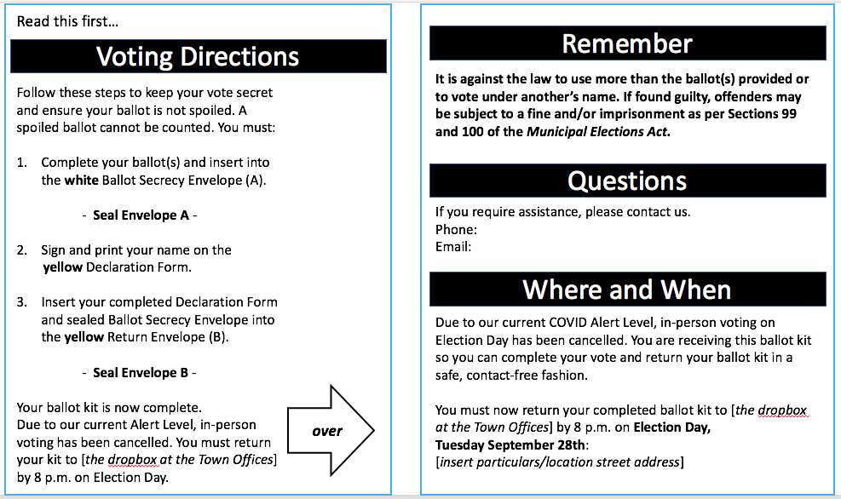

FORM VBM-2

EMERGENCY UPDATE VOTING DIRECTIONS cont’d

BACK:
Remember

It is against the law to use more than the ballot(s) provided or to vote under another’s name. If found guilty, offenders may be subject to a fine and/or imprisonment as per Sections 99 and 100 of the Municipal Elections Act.

Questions

If you require assistance, please contact us.
[Insert contact info - ideally phone # and email]

Where and When

Due to our current COVID Alert Level, in-person voting on Election Day has been cancelled. You are receiving this ballot kit so you can complete your vote and return your ballot kit in a safe, contact-free fashion.
You must now return your completed ballot kit to [insert instruction, e.g. the dropbox at the Town Offices] by 8 p.m. on Election Day, Tuesday September 28th:
[insert particulars/location street address]

FORM VBM-3

BALLOT SECRECY ENVELOPE
Use a non-transparent, WHITE envelope
(sized to fit 8-1/2” x 11” ballot and inside Return Envelope - Appendix F)

FRONT:
The following text shall be printed using large plain fonts (for legibility) in black ink:

A

Ballot Secrecy Envelope

Mock-up:

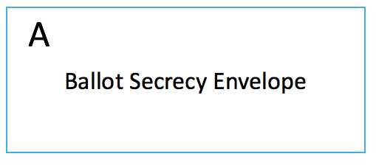

BACK:
The following text shall be printed using large plain fonts (for legibility) in black ink:

Enclose completed ballot(s) only.

Mock-up:
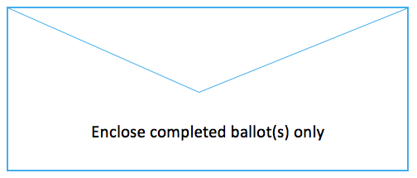
FORM VBM-4

RETURN ENVELOPE
Use a YELLOW envelope (colour similar to Declaration Form - Appendix C)
Sized to readily fit enclosed Ballot Secrecy Envelope - Appendix E.

FRONT:
The following text shall be printed using large plain fonts (for legibility) in black ink:

B

Return Envelope

See Directions for return location(s)

Mock-up:
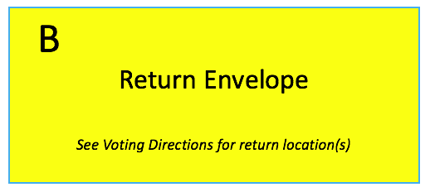

BACK:
The following text shall be printed using large plain fonts (for legibility) in black ink:

Have you enclosed your
- Sealed Ballot Secrecy Envelope?
- Signed Declaration Form?

Mock-up:
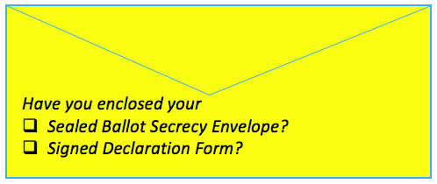

FORM VBM-5

NOTICE OF CANDIDATES
Replaces 2021 MAPA Required Form MEF-04

Municipality of ____________________ Municipal Election

The following persons have been nominated for election to council:
For Councillor | For Mayor  (if applicable) | For Ward Councillor  (if applicable)

Vote By Mail
The Town of [insert] is conducting the 2021 Municipal Election using Vote By Mail. Voter Kits will be available for all eligible voters commencing [insert date].

[Insert distribution details, e.g.
Voter Kits will be distributed automatically to the listed civic address of all voters on the Voters List.
OR
Voter Kit pick-ups will take place on:
1. ____________ the ______ day of __________, 20__ between the hours of [insert, e.g. 8:00 a.m. and 8:00 p.m.] at [insert location]
and (repeat as required if others are planned)…
AND/OR
Voters may [also] pick-up their Voter Kits at the Town Offices during regular working hours up to and including the day preceding Election Day.

The General Municipal Election
Election will take place on Tuesday the 28th day of September, 2021 between the hours of
8:00 a.m. and 8:00 p.m.
Polling booths for any eligible voters who have not already voted using a Voter Kit will be located at the following locations: [insert table with location details]

_________________________
Signature of Returning Officer

In addition to the public notification requirements, please also send this form to the appropriate
Regional Office of the Department of Municipal and Provincial Affairs immediately after the close of nominations.
FORM VBM-6

POLL BOX VOTE BY MAIL TALLY SHEET - VOTER KITS PROCESSED

Polling Division: _________________________ Box #_____________ Sheet #_____

Date |  | RO/DRO Initials
 | Poll Box sealed
THIS TALLY SHEET TO REMAIN WITH POLL BOX

Date | Voter Kits Rec’d | # Not Processed  Record reason/action verso | # of Ballot Secrecy Envelopes added to Ballot Box | Running  Total | Checked by  (initials)

FORM VBM-6

PER-POLL BOX TALLY SHEET - VOTER KITS PROCESSED (verso)

Voter Kits Not Processed for Polling Division:____________________ Box:___________

Date | Voter Kit  ID  (Declaration #) | Reason Not Processed | ACTION | Checked by  (initials)

For purposes of the Statement of Polling Division (MEF-16), this Poll Box Tally records
pre-Election Day VBM subtotals to be added to ballot numbers collected on Election Day.

FORM VBM-7

ELECTION DAY DIRECTIONS FOR THE GUIDANCE OF VOTERS
Replaces 2021 MAPA Required Form MEF-14

ACCESSIBILITY NOTE: Produce in large font.

The voter shall go into the Polling Booth, and with the pencil provided, mark an X on the right hand side of the ballot opposite the name of the candidate(s) for whom the voter wishes to vote.

The voter shall fold their completed ballot(s), enclose them in the Ballot Secrecy Envelope and seal the envelope.

The voter shall then either return the Ballot Secrecy Envelope to the Returning Officer or the Deputy Returning Officer or place it in the ballot box and then immediately leave the Polling Station.

If the voter inadvertently spoils a ballot, the voter may return it to the Returning Officer or Deputy Returning Officer who will, where satisfied that the spoiling of the ballot was by mistake, give the voter another ballot.

If the voter votes for more candidates than the voter is permitted to vote for, the voter’s ballot will be void and will not be counted for any of the candidates.

If the voter places a mark on the ballot by which the voter may afterwards be identified or if the ballot has been torn, defaced, or otherwise dealt with by the voter so that the voter can be identified, it will be void and will not be counted.

If the voter takes a ballot out of the Polling Station or places in the ballot box a ballot other than the one given to the voter by the Returning Officer or the Deputy Returning Officer, the voter commits an offence under the Municipal Elections Act and upon conviction is subject to a fine or imprisonment or both.

