VBM Kit Part 3
Appendices B & C Templates

Voter Kit Appendices

NOTE: These appendices to your Regulations should be included in your VBM Regulations package submission. They address the replacement of the serially-number, prescribed form of ballots called for by the MEA for standard elections and which don’t work for vote by mail processes.

Appendix B- Voter Declaration Form
Appendix C - Ballot (versions replacing MEF-5, -6 & -7)
APPENDIX B

NOTE: As appropriate, these templates reflect the design guidance provided by MAPA in their 2021 Municipal Election Forms publication for similar required forms (e.g. ballots, directions to voters) used in default election circumstances pursuant to the MEA.

Unless otherwise indicated, all other forms and procedures will generally follow the 2021 MAPA election guidance materials (i.e. 2021 Municipal Election Forms, Guide to Municipal Elections for Elections Officials) available at:
https://www.gov.nl.ca/mpa/local-governance-division/municipal-elections/

VOTER DECLARATION FORM

Use 8-1/2” x 11” paper stock - YELLOW (to match Return Envelope)

NOTE: This is the controlled material in the distributed ballot kits; it replaces the conventional serially-numbered ballots for elections conducted by in-person voting (only).

The following text shall be printed using large plain fonts and spacing (for legibility) in black ink:

Single-sided, serially-numbered
Declaration Form

I, the undersigned, declare that I am a Canadian Citizen, 18 years of age or older, eligible to vote in this election, and that I have not already voted for any office on this ballot.

_________________________________
Signature
_________________________________
Print name

[insert serial numbering]

Mock-up:
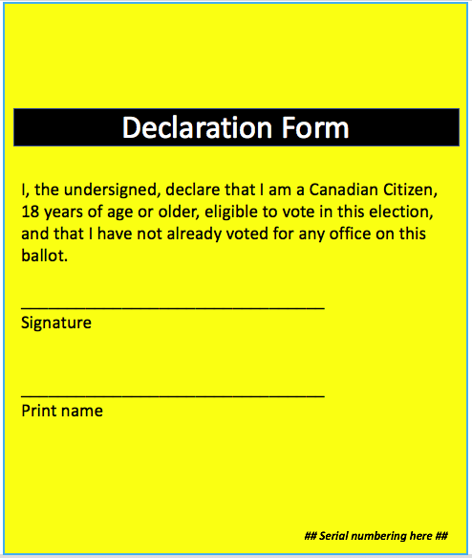
APPENDIX C

BALLOT (Various)
Replaces 2021 MAPA Required Forms MEF 5, 6 & 7

Use standard 8-1/2” x 11” paper stock
Use a different colour of paper for each type of ballot needed (e.g. white for Councillors; pale green for Mayor…)

The following text shall be printed using large plain fonts and spacing (for legibility) in black ink:
Municipality of [insert] Municipal Election

Ballot - [insert position, i.e. Councillor/Mayor/Ward Councillor, as appropriate]

Vote for up to [insert #] candidates OR Vote for one candidate only, as appropriate

# | Candidate | Mark an “X”
1
2
3
4
5
6
7

Mock-up examples:

